Hands-On Lab
Lab Manual
Creating Rich Reading Experiences in Windows Presentation Foundation Applications

Please do not remove this manual from the lab

Information in this document is subject to change without notice. The example companies, organizations, products, people, and events depicted herein are fictitious. No association with any real company, organization, product, person or event is intended or should be inferred. Complying with all applicable copyright laws is the responsibility of the user. Without limiting the rights under copyright, no part of this document may be reproduced, stored in or introduced into a retrieval system, or transmitted in any form or by any means (electronic, mechanical, photocopying, recording, or otherwise), or for any purpose, without the express written permission of Microsoft Corporation.

Microsoft may have patents, patent applications, trademarked, copyrights, or other intellectual property rights covering subject matter in this document. Except as expressly provided in any written license agreement from Microsoft, the furnishing of this document does not give you any license to these patents, trademarks, copyrights, or other intellectual property.

© 2005 Microsoft Corporation. All rights reserved.

Microsoft, MS-DOS, MS, Windows, Windows NT, MSDN, Active Directory, BizTalk, SQL Server, SharePoint, Outlook, PowerPoint, FrontPage, Visual Basic, Visual C++, Visual J++, Visual InterDev, Visual SourceSafe, Visual C#, Visual J#, and Visual Studio are either registered trademarks or trademarks of Microsoft Corporation in the U.S.A. and/or other countries.

Other product and company names herein may be the trademarks of their respective owners.

Contents
Lab 1: Creating Rich Reading Experiences in Windows Presentation Foundation Applications 1
Lab Objective 1
Task 1 – Create and customize a FlowDocument 2
Step 1 – Customizing columniation 3
Step 2 – Create a FlowDocument with Justification and Hyphenation 5
Step 3 – Styling the text 6
Step 4 –OpenType font features 8
Step 5 – Add figures and floaters 9
Task 2 –Transform Generic XML Articles to XAML 13
Step 1 – Add a simple UI to switch between documents 14
Step 2 – Hook up the transform to the Article buttons 15
Step 3 – Create the code to apply an XSLT to generate XAML 16
Step 4 – Tweak the XSLT used to transform generic XML articles to XAML 17
Task 3 – Annotations 19
Step 1 – Add a Menu for Annotations 19
Step 2 – Create the AnnotationService and Streams for Storing User Annotations 20
Step 3 – Create the event handlers for the new menu items 22
Task 4 – Add the Ability to Serialize Articles to XAML or XPS 23
Step 1 – Add two buttons to access this functionality 23
Step 2 – Enable serialization to XAML 24
Step 3 – Enable serialization to XPS 25
Appendix A: Fonts 25

Lab 1: Creating Rich Reading Experiences in Windows Presentation Foundation Applications

Lab Objective
Estimated time to complete this lab: 90 minutes
The objective of this lab is to create a Microsoft Encarta article reader using Windows Presentation Foundation (WPF) to take advantage of platform services such as pagination, columns, advanced typography features, and XPS.

- Create a FlowDocument with figures and floaters and customize the FlowDocument’s layout and style the text.
- Create and use an XSLT to transform generic xml articles into XAML.
- Enable annotations including highlighting and sticky notes.
- Add the ability to serialize articles to XAML and XPS.

Note: code snapshots representing the start-point for each task in the lab are available beneath the c:\Microsoft Hands-On-Lab\HOL-PRSHOL05\Source folder. These may be useful if you want to begin the lab somewhere in the middle, or if your project gets into an unrecoverable state.

The Microsoft WinFX Software Development Kit (SDK) has been installed on this computer, and is available by clicking the “WinFX SDK” shortcut in the Start menu. Users are encouraged to keep the SDK open during their lab experience in order to develop a deeper knowledge of relevant concepts and find answers to common questions. Application Programming Interface (API) reference documentation is also available within the SDK.
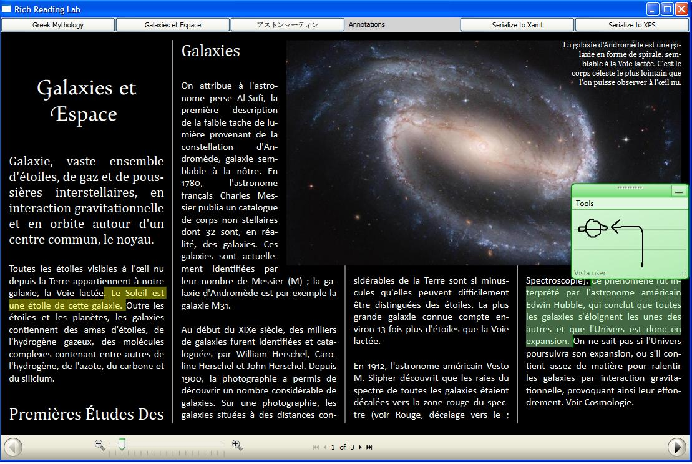

Task 1 – Create and customize a FlowDocument
In this exercise, you will create a FlowDocument version of a Microsoft Encarta article. You will learn how to use:
- Adaptive pagination and columniation with justification and hyphenation
- Styling for text content
- OpenType font features
- Floaters and figures
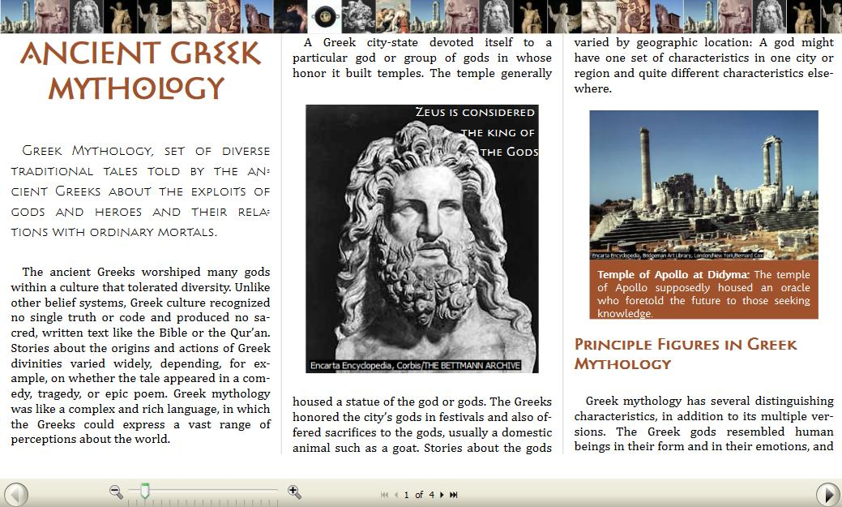

Step 1 – Customizing columniation
Start Visual Studio 2005: From the desktop click Start, click All Programs, and then locate and click Microsoft Visual Studio 2005 Beta 2.
- After Visual Studio opens, on the main menu click File, select Open, and then click Project/Solution. Locate the Reading Experience Lab folder under C:\Microsoft Hands-On-Lab\HOL-PRSHOL05\Source\vb\, click to open the Task1 folder, and then double-click on RichReadingLab.sln.
The RichReadingLab.sln project contains all the image and XML content as well as a very generic FlowDocument containing a Microsoft Encarta article on Greek mythology.
- On the main menu, click Debug, and then click Start Debugging (or press F5 on the keyboard). The application will compile, and then after a few moments start executing. When the "Rich Reading Lab" window opens, play with the zoom thumb and page forward / page backward controls at the bottom of the page to get a feel for how the FlowDocumentReader operates. When finished, close the window by clicking the "X" in the upper-right corner.
- Back in Visual Studio, in the right "Solution Explorer" pane, double-click on Window1.xaml, and then change the default column width and gap by adding the following two properties:
<FlowDocumentReader Name="greekFlowDocumentReader">
<FlowDocument
ColumnWidth="6.5 cm"
ColumnGap="0.7 cm" >
The typeconverters allow you to specify a variety of units in markup including metric, English, and pixels.
- Add a gray rule to visually separate each column:
<FlowDocumentReader Name="greekFlowDocumentReader">
<FlowDocument
ColumnWidth="6.5 cm"
ColumnGap="0.7 cm"
ColumnRuleWidth="1 px"
ColumnRuleBrush="LightGray" >
- Disable column balancing and allow column widths to be flexible:
<FlowDocument
ColumnWidth="6.5 cm"
ColumnGap="0.7 cm"
ColumnRuleWidth="1 px"
ColumnRuleBrush="LightGray"
IsColumnWidthFlexible="True">

- Press F5 to compile and run the program with the changes you've made. When the "Rich Reading Lab" window opens, click on the right window border and change its size. Notice how the FlowDocument automatically adjusts the column widths and number of columns per page to take best advantage of the available screen space.
With the column width is set to be flexible, the FlowDocument will distribute content evenly to each column (see figure below).
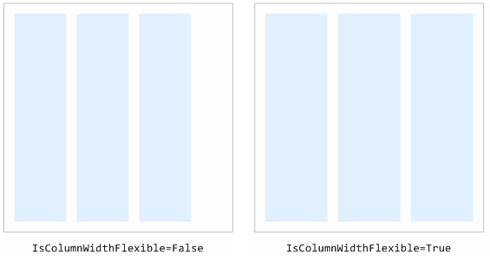
When finished, close the Rich Reading Lab window by clicking the "X" in the upper-right corner.

Step 2 – Create a FlowDocument with Justification and Hyphenation
- Back in Visual Studio in Window1.xaml, now set the text alignment to be justified:
<FlowDocumentReader Name="greekFlowDocumentReader">
<FlowDocument
ColumnWidth="6.5 cm"
ColumnGap="0.7 cm"
ColumnRuleWidth="1 px"
ColumnRuleBrush="LightGray"
IsColumnWidthFlexible="True"
TextAlignment="Justify" >
<FlowDocument.Resources>
- Press F5 to recompile and run the application. Notice the large gaps of white space in the text after setting the alignment to justify. When finished, close the Rich Reading Lab window by clicking the "X" in the upper-right corner.
- Now turn on hyphenation:
<FlowDocumentReader Name="greekFlowDocumentReader">
<FlowDocument
ColumnWidth="6.5 cm"
ColumnGap="0.7 cm"
ColumnRuleWidth="1 px"
ColumnRuleBrush="LightGray"
IsColumnWidthFlexible="True"
TextAlignment="Justify"
IsHyphenationEnabled="True" >
<FlowDocument.Resources>

- Press F5 to recompile and run the application. Notice how, where appropriate, words have been hyphenated and split to multiple lines (see figure below). When finished, close the Rich Reading Lab window by clicking the "X" in the upper-right corner.

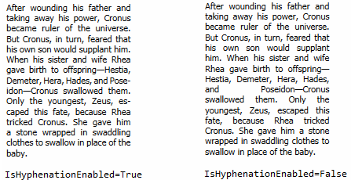
Hyphenation will break words appropriately to achieve a more even distribution of white space in justified text.

Step 3 – Styling the text
This lab uses new fonts that will be available on Windows Vista as well as fonts that will be included in the Windows Presentation Foundation SDK. To learn more about these fonts and their special OpenType features, see the Appendix.
- Add styling to the title text by first finding the Style x:Key="Title" element under FlowDocuments.Resources:
<FlowDocument.Resources>
<Style x:Key="Title" TargetType="{x:Type Paragraph}">
<!-- To be added in Task 1 Step 3-->
</Style>
Within this Style element create Setter elements to modify the font properties. Also create one to turn off hyphenation on the title text.
<FlowDocument.Resources>
<Style x:Key="Title" TargetType="{x:Type Paragraph}">
<Setter Property="FontFamily" Value="Pericles" />
<Setter Property="FontWeight" Value="Bold" />
<Setter Property="FontSize" Value="26 pt" />
<Setter Property="TextAlignment" Value="Center" />
<Setter Property="Foreground" Value="Sienna" />
<Setter Property="IsHyphenationEnabled" Value="False" />
</Style>

Notice that the project already has the correctly set Style properties set on each Paragraph element:
<!-- Title Text -->
<Paragraph Style="{StaticResource Title}">
ANCIENT GREEK MYTHOLOGY
</Paragraph>

Press F5 to recompile and see the title text with the new styling. When finished, close the Rich Reading Lab window by clicking the "X" in the upper-right corner.
- Do the same for the headings, body text, and first paragraph:
<FlowDocument.Resources>
<Style x:Key="Title" TargetType="{x:Type Paragraph}">
<Setter Property="FontFamily" Value="Pericles" />
<Setter Property="FontWeight" Value="Bold" />
<Setter Property="FontSize" Value="26 pt" />
<Setter Property="TextAlignment" Value="Center" />
<Setter Property="Foreground" Value="Sienna" />
<Setter Property="IsHyphenationEnabled" Value="False" />
</Style>

<Style x:Key="Heading" TargetType="{x:Type Paragraph}"
BasedOn="{StaticResource Title}">
<Setter Property="FontSize" Value="14 pt" />
<Setter Property="TextAlignment" Value="Left" />
<Setter Property="KeepWithNext" Value="True" />
</Style>

<Style x:Key="BodyText" TargetType="{x:Type Paragraph}">
<Setter Property="TextIndent" Value="14 px" />
<Setter Property="FontFamily" Value="Cambria, Georgia" />
<Setter Property="FontSize" Value="12 pt" />
</Style>

<Style x:Key="FirstParagraph" TargetType="{x:Type Paragraph}"
BasedOn="{StaticResource BodyText}">
<Setter Property="FontFamily" Value="Pericles Light" />
<Setter Property="LineHeight" Value="25 px" />
</Style>
</FlowDocument.Resources>

Notice that the Style properties on each of the Paragrahs in the project are already set properly for you in Window1.xaml:
<!-- First Paragraph -->
<Paragraph Style="{StaticResource FirstParagraph}">
Greek Mythology, set of diverse traditional tales...
</Paragraph>

<Paragraph Style="{StaticResource BodyText}">
The ancient Greeks worshiped many gods...
</Paragraph>

<!-- Heading -->
<Paragraph Style="{StaticResource Heading}">
Principle Figures in Greek Mythology
</Paragraph>
Press F5 to recompile and see the new first paragraph, body text, and heading styles. When finished, close the Rich Reading Lab window by clicking the "X" in the upper-right corner.

Step 4 –OpenType font features
Take advantage of the OpenType font features in the Pericles font by setting the Typography.DiscretionaryLigatures and Typography.StylisticAlternates properties. Many OpenType fonts like the ones being used through this lab have alternate character forms that use ligatures, swashes, and different styles. These features are exposed through the Typography.* properties.
Note: Not all fonts have Typography features and most fonts that do only implement a subset of the total features available.

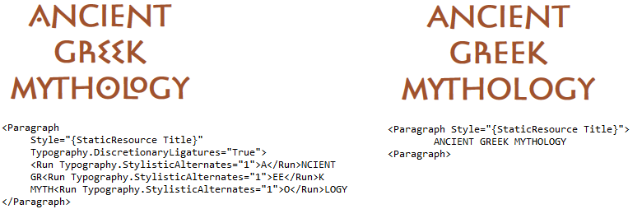 | <!-- Title Text-->  <Paragraph Style="{StaticResource Title}">  ANCIENT GREEK MYTHOLOGY  </Paragraph>

<!-- Title Text-->
<Paragraph Style="{StaticResource Title}"
Typography.DiscretionaryLigatures="True">
<Run
Typography.StylisticAlternates="1">A</Run>NCIENT
GR<Run Typography.StylisticAlternates="1">EE</Run>K
MYTH<Run
Typography.StylisticAlternates="1">O</Run>LOGY
</Paragraph>

Note: Run and other Inline derived elements can be used to apply properties within Paragraphs.

The OpenType features available in the Pericles font are listed in the table below:
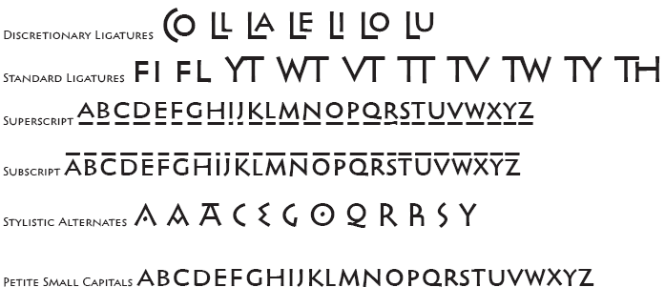
This and other OpenType sample fonts will be available in the Windows SDK Sample OpenType Font pack. See the Appendix for more details.

Step 5 – Add figures and floaters
- Add a figure to display as a top banner:
<!-- Title Text -->
<Paragraph
Style="{StaticResource Title}"
Typography.DiscretionaryLigatures="True">
<Run Typography.StylisticAlternates="1">A</Run>NCIENT
GR<Run Typography.StylisticAlternates="1">EE</Run>K
MYTH<Run Typography.StylisticAlternates="1">O</Run>LOGY
<Figure
Padding="0,0,0,0"
Margin="0,0,0,0"
Width="Page"
HorizontalAnchor="PageCenter"
VerticalAnchor="PageTop">
<BlockUIContainer>
<Image Source="Banner.jpg"/>
</BlockUIContainer>
</Figure>
</Paragraph>
- Framework elements like Image or MediaElement need to be wrapped within a BlockUIContainer.
- Figure and Floater elements must be wrapped within a Paragraph.
Press F5 to recompile and see the new banner image. When finished, close the Rich Reading Lab window by clicking the "X" in the upper-right corner.
- Add a figure of Zeus to the middle of the first displayed page:
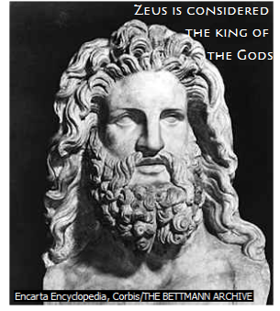
<!-- First Paragraph -->
<Paragraph Style="{StaticResource FirstParagraph}">
Greek Mythology, set of diverse traditional...
<Figure
HorizontalAnchor="PageCenter"
VerticalAnchor="PageCenter"
Width = ".3 Page" >
<BlockUIContainer>
<Viewbox>
<Grid>
<ColumnDefinition />
<RowDefinition />
<Image
Grid.Row="0"
Grid.Column="0"
Source="Zeus.jpg" />
<TextBlock
Grid.Row="0"
Grid.Column="0"
Foreground="White"
VerticalAlignment="Top"
TextAlignment="Right"
FontFamily="Pericles"
FontSize="11pt">
Zeus is considered <LineBreak />
the king of <LineBreak />
the Gods
</TextBlock>
</Grid>
</Viewbox>
</BlockUIContainer>
</Figure>
</Paragraph>
Press F5 to recompile and see the image of Zeus on the first page. Change the window size to change the number of columns and notice how Zeus stays centered on the page. When finished, close the Rich Reading Lab window by clicking the "X" in the upper-right corner.
A Viewbox ensures that the size of the text does not increase during resizing. This guarantees that the text will not flow into Zeus’ head.
The Figure element uses a Grid of one cell to lay text on top of an image.
You can set a width or height to the Figure using various metrics(e.g. “0.5 in”, “2.5 cm”, “.5 page”, “2.5 columns”)
<LineBreak /> similar to HTML’s <BR /> can be used to manually break lines in your text.
- Add a Floater with a small image and caption of the Apollo temple:
<!-- An image of the temple of Apollo and caption will be
added here in Task 1 Step 5-->
<Paragraph Style="{StaticResource BodyText}">
Two other Olympian divinities, Hephaestus and Athena, had unusual...
<Floater>
<BlockUIContainer>
<DockPanel>
<Image DockPanel.Dock="Top" Source="Apollo.jpg"/>
<TextBlock
DockPanel.Dock="Bottom"
Padding="10,10,10,10"
Background="Sienna"
Foreground="White">
FontFamily="Kootenay" FontSize="10pt">
<Run FontWeight="Bold">Temple of Apollo at Didyma: </Run>
The temple of Apollo supposedly housed an oracle who
foretold the future to those seeking knowledge.
</TextBlock>
</DockPanel>
</BlockUIContainer>
</Floater>
</Paragraph>
Press F5 to recompile and see the image of the Temple of Apollo at Didyma. Change the window size to change the number of columns and notice how the image and its caption stay placed within a single column. When finished, close the Rich Reading Lab window by clicking the "X" in the upper-right corner.
A Floater can be used to display related information or decoration within a text layout. The two main differences between Figure and Floater are:
- A Figure can be positioned relative to the page to which it's anchored (e.g. the bottom of the page); a Floater can always be positioned within the main flow of text.
- A Figure can span across multiple columns; a Floater is constrained within a single column.
There is an unused image in the project named “Laocoon.JPG”, feel free to add it as a Figure or Floater using what you’ve learned so far.
- Add a Floater with a pull quote:
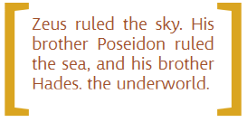
<!-- A pull quote will be added here in Task1 Step 5 -->
<Paragraph Style="{StaticResource BodyText}">
When fully grown, Zeus forced his father to disgorge...
<Floater>
<BlockUIContainer>
<Viewbox>
<DockPanel LastChildFill="True">
<TextBlock
DockPanel.Dock="Left"
FontFamily="Kootenay"
FontSize="200px"
Foreground="GoldenRod"
VerticalAlignment="Center">
[
</TextBlock>
<TextBlock
DockPanel.Dock="Right"
FontFamily="Kootenay"
FontSize="200px"
Foreground="GoldenRod"
VerticalAlignment="Center">
]
</TextBlock>
<TextBlock
Width="300px"
Height="125px"
VerticalAlignment="Center"
FontFamily="Kootenay"
FontSize="28px"
Foreground="Sienna"
TextWrapping="Wrap"
TextAlignment="Justify"
IsHyphenationEnabled="True">
Zeus ruled the sky. His brother Poseidon
ruled the sea, and his brother Hades,
the underworld.
</TextBlock>
</DockPanel>
</Viewbox>
</BlockUIContainer>
</Floater>
</Paragraph>
To create the pull quote wrapped with parenthesis, the Floater uses a DockPanel with the parenthesis docked to the sides and the text filling the remaining space. The Viewbox ensures that the text does not reflow improperly.

Task 2 – Transform Generic XML Articles to XAML
In this exercise, you will transform generic XML articles to XAML by doing the following:
- Add a simple UI to switch between documents
- Create the C# or VB code to apply an XSLT to generate XAML that can be viewed through a FlowDocumentReader.
- Tweak the XSLT by taking advantage of OpenType font features and adding an additional style of illustration.

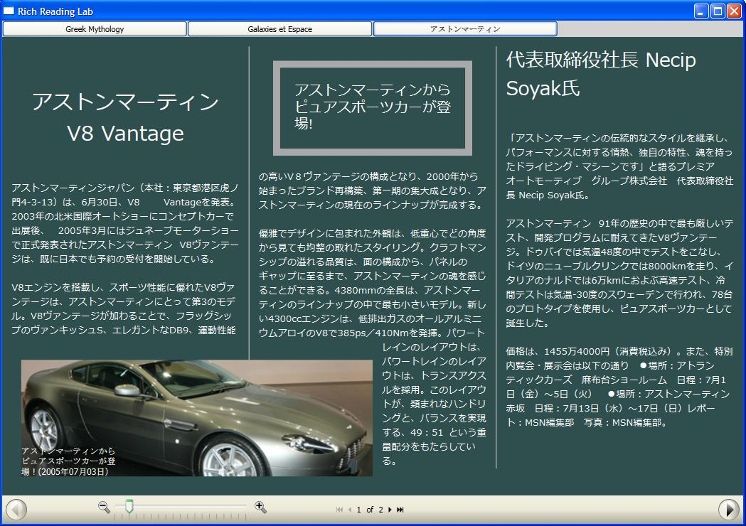

Step 1 – Add a simple UI to switch between documents
If not open already, start Visual Studio 2005 (from the desktop click Start, click All Programs, and then locate and click Microsoft Visual Studio 2005 Beta 2. After Visual Studio opens, on the main menu click File, select Open, and then click Project/Solution.
- Locate the Reading Experience Lab folder under C:\Microsoft Hands-On-Lab\HOL-PRSHOL05\Source\vb\, click to open the Task2 folder, and then double-click on RichReadingLab.sln.
- On the main menu, click Debug, and then click Start Debugging (or press F5 on the keyboard). The application will compile, and then after a few moments start executing. When the "Rich Reading Lab" window opens, play with the zoom thumb and page forward / page backward controls at the bottom of the page to get a feel for how the FlowDocumentReader operates. When finished, close the window by clicking the "X" in the upper-right corner.
- Back in Visual Studio, in the right "Solution Explorer" pane, double-click on Window1.xaml.
- Wrap the FlowDocumentReader in a DockPanel.
<Window x:Class="RichReadingLab.Windows1"
:
<DockPanel Name="dockPanel">
<FlowDocumentReader Name="greekFlowDocumentReader">
:
</FlowDocumentReader>
</DockPanel>
</Window>
- Immediately after the opening the DockPanel element, add a Grid that will dock to the top of the DockPanel using the DockPanel.Dock attached property. Make the Grid a six cell grid by adding a <Grid.ColumnDefinitions> element containing six <ColumnDefinition /> elements, and a <Grid.RowDefinitions> element containing one <RowDefinition />. In this exercise we’ll add three buttons to switch between articles. In the next exercise we’ll add two more buttons for serializing the content and a menu for annotations.
- Add the below buttons.
<DockPanel Name="dockPanel">
<Grid DockPanel.Dock="Top" Background="LightGray">
<Grid.ColumnDefinitions>
<ColumnDefinition />
<ColumnDefinition />
<ColumnDefinition />
<ColumnDefinition />
<ColumnDefinition />
<ColumnDefinition />
</Grid.ColumnDefinitions>
<Grid.RowDefinitions>
<RowDefinition />
</Grid.RowDefinitions>

<Button Grid.Column="0" Grid.Row="0" Name="greekButton"
Click="ButtonClick">
Greek Mythology
</Button>
<Button Grid.Column="1" Grid.Row="0" Name="galaxiesButton"
Click="ButtonClick">
Galaxies et Espace
</Button>
<Button Grid.Column="2" Grid.Row="0" Name="carsButton"
Click = "ButtonClick">
アストンマーティン (Aston)
</Button>
</Grid>
<FlowDocumentReader Name="greekFlowDocumentReader">

Step 2 – Hook up the transform to the Article buttons
To switch between each of the articles, we will create a new FlowDocumentReader for each article and use ‘currentFlowDocumentReader’ to track the currently viewed FlowDocumentReader. In the Visual Studio right "Solution Explorer" pane (if not visible, from the main menu click View and then click Solution Explorer), double-click on Window1.xaml.vb to open, and then add the following to the Window1 class within Window1.xaml.vb:
Partial Public Class Window1
Inherits Window
' Different FlowDocumentReaders for each article
' greekFlowDocumentReader already defined in XAML
Private galaxiesFlowDocumentReader As FlowDocumentReader = New FlowDocumentReader
Private carsFlowDocumentReader As FlowDocumentReader = New FlowDocumentReader
Private currentFlowDocumentReader As FlowDocumentReader

Public Sub New()
InitializeComponent()
' Creates a FlowDocument from the XML files and assigns the FlowDocument to
' the proper FlowDocumentReader
galaxiesFlowDocumentReader.Document = ConvertXmlToFlowDocument("Galaxies.xml")
carsFlowDocumentReader.Document = ConvertXmlToFlowDocument("Cars.xml")

' App starts off with the greek article, so set the currentFlowDocumentReader
' and currentAnnotService to reflect this.
currentFlowDocumentReader = greekFlowDocumentReader
End Sub
After the New () constructor, add an EventHandler which will be called whenever any of the newly added buttons are clicked. Create the logic in the EventHandler to handle the switching between FlowDocumentReaders:
' This function handles the article switching
Private Sub ButtonClick(ByVal sender As Object, ByVal e As RoutedEventArgs) Handles greekButton.Click, galaxiesButton.Click, carsButton.Click

Select Case CType(sender, Button).Name
Case "galaxiesButton"
' Remove the FlowDocumentReader that's in view now and add in the
' desired one
dockPanel.Children.Remove(currentFlowDocumentReader)
dockPanel.Children.Add(galaxiesFlowDocumentReader)
currentFlowDocumentReader = galaxiesFlowDocumentReader

Case "carsButton"
' Remove the FlowDocumentReader that's in view now and add in the
' desired one
dockPanel.Children.Remove(currentFlowDocumentReader)
dockPanel.Children.Add(carsFlowDocumentReader)
currentFlowDocumentReader = carsFlowDocumentReader
Case Else
' Remove the FlowDocumentReader that's in view now and add in the
' desired one
dockPanel.Children.Remove(currentFlowDocumentReader)
dockPanel.Children.Add(greekFlowDocumentReader)
currentFlowDocumentReader = greekFlowDocumentReader
End Select
End Sub

Note: The reason this code switches the FlowDocumentReader instead of switching the FlowDocument in the FlowDocumentReader is to improve the performance and stability of annotations that will be added in Step 3. This allows us to switch between the three articles without disabling the AnnotationService.

Step 3 – Create the code to apply an XSLT to generate XAML
In Window1.xaml.vb, create a function that will take in a string specifying an XML page and output a FlowDocument object:
' Function takes in a name of a FlowDocument XAML file and converts it into a
' FlowDocument object
Private Function ConvertXmlToFlowDocument(ByVal FileName As String) As _
FlowDocument

' Create an object representing the xml file
Dim originalXML As XPath.XPathDocument = New XPath.XPathDocument(FileName)

' Create an object representing the XSLT
Dim xslt As Xsl.XslCompiledTransform = New Xsl.XslCompiledTransform()
xslt.Load("GenericToXaml.xslt")

' Create a memory stream to store the results of the XSLT
Dim memStream As MemoryStream = New MemoryStream()

' Apply the XSLT transform
xslt.Transform(originalXML, New Xsl.XsltArgumentList(), memStream)

' Use this line for debugging your XSLT:
' xslt.Transform(originalXML, New XmlTextWriter(Console.Out))

' Parse the new XAML in the memory stream and convert it into a FlowDocument
' object
Dim flowDocument As FlowDocument = New FlowDocument()
memStream.Seek(0, SeekOrigin.Begin)

flowDocument = Windows.Serialization.Parser.LoadXml(memStream)

memStream.Close()

Return flowDocument
End Function
Press F5 to recompile. Click on the “Galaxies et Espace” and “アストンマーティン (Aston)” buttons to see the XAML versions of the generic articles. When finished, close the Rich Reading Lab window by clicking the "X" in the upper-right corner.

Step 4 – Tweak the XSLT used to transform generic XML articles to XAML
- Using Visual Studio, in the right "Solution Explorer" pane, double-click and examine Galaxies.xml and Cars.xml. These are the generic XML articles that your XSLT must convert into XAML. These XML articles contain four main elements: Title, Heading, Para, and Illustration (Small and Medium) which have mappings to XAML in the XSLT.
- Again in the Visual Studio "Solution Explorer" pane, double-click to open GenericToXAML.xslt. GenericToXAML.xslt is structured as follows:

  - When the XSLT is performed, the root element <Article> in Galaxies.xml and Cars.xml will be replaced by the contents of <xsl:template match="/"> (in XPath language ‘/’ represents the root element).
  - Each of the XML elements in Galaxies.xml and Cars.xml have a corresponding <xsl:template match=""> element to determine what the XML element will be transformed to. For example <Title> will be transformed to <Paragraph Style="{{StaticResource Title}}">
- In Visual Studio "Solution Explorer", double-click and open Galaxies.xml. Notice that there are <Swash> elements which do not have a corresponding <xsl:template match=""> element in the XSLT.
<Title>
<Swash>G</Swash>alaxies
et
<Swash>E</Swash>space
</Title>
In Visual Studio "Solution Explorer", double-click and open GenericToXAML.xslt. Add a Swash template:

<!-- Add the Swash template below here: -->
<xsl:template match="Swash">
<Run Typography.StandardSwashes="2">
<xsl:apply-templates/>
</Run>
</xsl:template>

Press F5 to recompile. Click on the “Galaxies et Espace” button, notice the new swashes in the title:
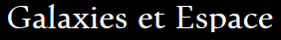 | 
<!-- Add the Swash template below here: --> | <!-- Add the Swash template below here: -->  <xsl:template match="Swash">  <Run Typography.StandardSwashes="2">  <xsl:apply-templates/>  </Run>  </xsl:template>

When finished, close the Rich Reading Lab window by clicking the "X" in the upper-right corner.
- In Visual Studio "Solution Explorer", double-click and open GenericToXAML.xslt. Add a new Illustration template to better display the large galaxy image in “Galaxies.xml”:

<!-- Add the <Illustration Style='Big'> template below here: -->
<xsl:template match="Illustration[@Style='Big']">
<Paragraph>
<Figure
HorizontalAnchor="PageRight"
VerticalAnchor="PageTop"
Width=".7 content">
<BlockUIContainer>
<Viewbox>
<Grid>
<Image>
<xsl:attribute name= 'Source'>
<xsl:value-of select="./Pic" />
</xsl:attribute>
</Image>
<TextBlock
VerticalAlignment="Top"
HorizontalAlignment="Right"
Width="400 px"
FontFamily="Cambria, Georgia, Meiryo, MS Gothic"
FontSize="20 pt"
TextAlignment="Right"
IsHyphenationEnabled="True">
<xsl:value-of select="./Caption" />
</TextBlock>
</Grid>
</Viewbox>
</BlockUIContainer>
</Figure>
</Paragraph>
</xsl:template>
The following template will create an Illustration that takes up 70% of the content space and is anchored to the top right of the page.

- In Visual Studio "Solution Explorer", double-click and open Galaxies.xml. Change the illustration style in Galaxies.xml to take advantage of this new XSLT template:
<!-- Generic xml for the French article on galaxies -->
<Article
DocumentStyle="SanSerifBody"
Background="Black"
Foreground="White">
<Illustration Style="Big">
<Pic>Galaxy1.JPG</Pic>

Press F5 to recompile. Click on the “Galaxies et Espace” button and notice the difference in illustration placement and size:

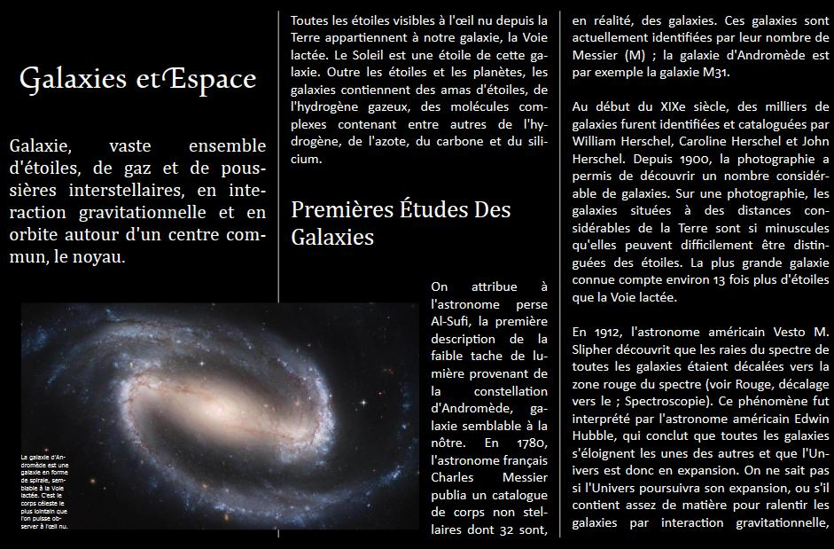 | 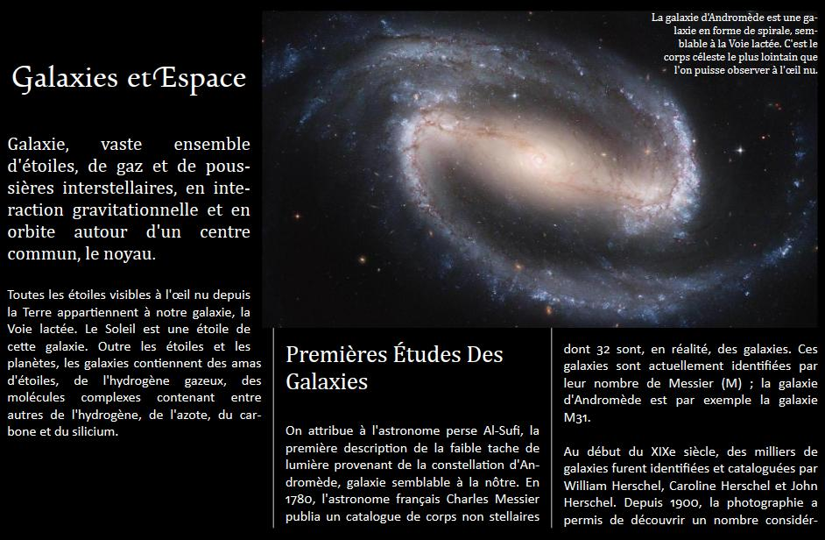
<Illustration Style="Medium"> | <Illustration Style="Big">

When finished, close the Rich Reading Lab window by clicking the "X" in the upper-right corner.

Task 3 – Annotations
If not open already, start Visual Studio 2005 (from the desktop click Start, click All Programs, and then locate and click Microsoft Visual Studio 2005 Beta 2. After Visual Studio opens, on the main menu click File, select Open, and then click Project/Solution.
- Locate the Reading Experience Lab folder under C:\Microsoft Hands-On-Lab\HOL-PRSHOL05\Source\vb\, click to open the Task3 folder, and then double-click on RichReadingLab.sln.
- On the main menu, click Debug, and then click Start Debugging (or press F5 on the keyboard). The application will compile, and then after a few moments start executing. When the "Rich Reading Lab" window opens, play with the zoom thumb and page forward / page backward controls at the bottom of the page to get a feel for how the FlowDocumentReader operates. When finished, close the window by clicking the "X" in the upper-right corner.
- Back in Visual Studio, in the right "Solution Explorer" pane, double-click on Window1.xaml.

Step 1 – Add a Menu for Annotations
Open Window1.xaml and add a new column to the grid holding the Article buttons. Then add a simple menu so users can add highlighting, text sticky notes, and ink sticky notes.
<Grid DockPanel.Dock="Top" Background="LightGray">
<Grid.ColumnDefinitions>
<ColumnDefinition />
<ColumnDefinition />
<ColumnDefinition />
<ColumnDefinition />
<ColumnDefinition />
<ColumnDefinition />
</Grid.ColumnDefinitions>
<Grid.RowDefinitions>
<RowDefinition />
</Grid.RowDefinitions>

<Button Grid.Column="0" Grid.Row="0" Name="greekButton" Click="ButtonClick">
Greek Mythology
</Button>

<Button Grid.Column="1" Grid.Row="0" Name="galaxiesButton" Click="ButtonClick">
Galaxies et Espace
</Button>

<Button Grid.Column="2" Grid.Row="0" Name="carsButton" Click="ButtonClick">
アストンマーティン
</Button>
<Menu Grid.Column="3" Grid.Row="0" Background="LightGray">
<MenuItem Header="Annotations">
<MenuItem.ToolTip>
Select text, then select one of the below choices
</MenuItem.ToolTip>
<MenuItem Name="highlightMenuItem" Header="Highlight"
Click="CreateHighlight" />
<MenuItem Name="textNoteMenuItem" Header="Text Sticky Note"
Click="CreateTextNote" />
<MenuItem Name="inkNoteMenuItem" Header="Ink Sticky Note"
Click="CreateInkNote" />
</MenuItem>
</Menu>
</Grid>

Step 2 – Create the AnnotationService and Streams for Storing User Annotations
The AnnotationService class enables you to add and store annotations you make on any document viewed in a DocumentViewer. AnnotationService requires that you pass in two objects:
- On instantiation, you must pass in the DocumentViewer or derived class (in this case FlowDocumentReader).
- When calling the Enable method, you must pass in a Stream defining where the user annotations are to be stored.

In Visual Studio "Solution Explorer", double-click to open Window1.xaml.vb. Add the following code to Window1.xaml.vb to create AnnotationServices for each of the articles and FileStreams to store the annotations. Create a currentAnnotService to track the AnnotationService that is currently in use. We’ll use this in ButtonClick() to switch between articles properly.
Partial Public Class Window1
Inherits Window

' Different FlowDocumentReaders for each article
' greekFlowDocumentReader already defined in XAML
Private galaxiesFlowDocumentReader As FlowDocumentReader = New FlowDocumentReader
Private carsFlowDocumentReader As FlowDocumentReader = New FlowDocumentReader
Private currentFlowDocumentReader As FlowDocumentReader

' AnnotationServices for each of the three different FlowDocumentReaders
Private greekAnnotService As AnnotationService
Private galaxiesAnnotService As AnnotationService
Private carsAnnotService As AnnotationService
Private currentAnnotService As AnnotationService

' FileStreams to store annotations
Private greekFileStream As FileStream = New FileStream("GreekAnnotations.txt", FileMode.OpenOrCreate)
Private galaxiesFileStream As FileStream = New FileStream("GalaxiesAnnotations.txt", FileMode.OpenOrCreate)
Private carsFileStream As FileStream = New FileStream("CarsAnnotations.txt", FileMode.OpenOrCreate)

Public Sub New()

Instantiate the AnnotationServices passing in the appropriate FlowDocumentReader. Then enable the annotations and pass in the appropriate FileStream:

Public Sub New()
InitializeComponent()

' Creates a FlowDocument from the XML files and assigns the FlowDocument to
' the proper FlowDocumentReader
galaxiesFlowDocumentReader.Document = ConvertXmlToFlowDocument("Galaxies.xml")
carsFlowDocumentReader.Document = ConvertXmlToFlowDocument("Cars.xml")

' Initialize the AnnotationServices and point them to their respective
' FlowDocumentReaders
greekAnnotService = New AnnotationService(greekFlowDocumentReader)
galaxiesAnnotService = New AnnotationService(galaxiesFlowDocumentReader)
carsAnnotService = New AnnotationService(carsFlowDocumentReader)

' Enable the AnnotationServices and point them to their respective
' FileStreams
greekAnnotService.Enable((New XmlStreamStore(greekFileStream))
galaxiesAnnotService.Enable((New XmlStreamStore(galaxiesFileStream))
carsAnnotService.Enable((New XmlStreamStore(carsFileStream))

' App starts off with the greek article, so set the currentFlowDocumentReader
' and currentAnnotService to reflect this.
currentFlowDocumentReader = greekFlowDocumentReader
currentAnnotService = greekAnnotService

End Sub

In the ButtonClick method, add logic to switch between the above annotation services when a new article is loaded:
Private Sub ButtonClick(ByVal sender As Object, ByVal e As RoutedEventArgs) _
Handles greekButton.Click, galaxiesButton.Click, carsButton.Click

Select Case CType(sender, Button).Name
Case "galaxiesButton"
' Remove the FlowDocumentReader that's in view now and add in
' the desired one
dockPanel.Children.Remove(currentFlowDocumentReader)
dockPanel.Children.Add(galaxiesFlowDocumentReader)
currentFlowDocumentReader = galaxiesFlowDocumentReader
currentAnnotService = galaxiesAnnotService
Case "carsButton"
' Remove the FlowDocumentReader that's in view now and add in
' the desired one
dockPanel.Children.Remove(currentFlowDocumentReader)
dockPanel.Children.Add(carsFlowDocumentReader)
currentFlowDocumentReader = carsFlowDocumentReader
currentAnnotService = carsAnnotService
Case Else
' Remove the FlowDocumentReader that's in view now and add in
' the desired one
dockPanel.Children.Remove(currentFlowDocumentReader)
dockPanel.Children.Add(greekFlowDocumentReader)
currentFlowDocumentReader = greekFlowDocumentReader
currentAnnotService = greekAnnotService
End Select
End Sub

Step 3 – Create the event handlers for the new menu items
Following the ButtonClick method, add the functions to match the Click properties set in the above XAML:
' Function to create highlighting
Private Sub CreateHighlight(ByVal sender As Object, ByVal e As RoutedEventArgs) Handles highlightMenuItem.Click

Try
Annotations.AnnotationHelper.CreateHighlightForSelection _
(currentAnnotService, "Vista user", Brushes.Yellow)
Catch exception As InvalidOperationException
' If someone tries to highlight without actually selecting text, do
' nothing.
End Try

End Sub
' Function to create a text note
Private Sub CreateTextNote(ByVal sender As Object, ByVal e As RoutedEventArgs) Handles textNoteMenuItem.Click

Try
Annotations.AnnotationHelper.CreateTextStickyNoteForSelection( _
currentAnnotService, "Vista user")
Catch exception As InvalidOperationException
' If someone tries to highlight without actually selecting text, do
' nothing.
End Try

End Sub
' Function to create an ink note
Private Sub CreateInkNote(ByVal sender As Object, ByVal e As RoutedEventArgs) Handles inkNoteMenuItem.Click

Try
Annotations.AnnotationHelper.CreateInkStickyNoteForSelection( _
currentAnnotService, "Vista user")
Catch exception As InvalidOperationException
' If someone tries to highlight without actually selecting text, do
' nothing.
End Try

End Sub

Press F5 on the keyboard. The application will compile and then after a few moments start executing. When the "Rich Reading Lab" window opens, select some text within an article, click on the Annotations button in the top menu bar, and then click on the type of annotation (Highlight, Text Sticky Note, or Ink Sticky Note) you wish to create. Even though the content of the RichReadingLab document is read-only, you can create user annotations within any of the content.
For example, by clicking Text Sticky Note, a text sticky note will appear and you can type a comment or message of your choice. You can minimize the sticky note by clicking on the minimize icon in the top-right corner of the annotation. To maximize the annotation again, click on the annotation icon that appears at the beginning of the original text selection. Resize the application window and notice how the annotation selections and the annotations themselves track with the original selection (anchor to the original user selection).
When finished exploring annotations, close the Rich Reading Lab window by clicking the "X" in the upper-right corner.
Note: AnnotationHelper is a static class that allows you to pass in an AnnotationService to create available types of annotations.
Note: AnnotationService will throw an exception when any AnnotationHelper.Create… method is called if there is no selected text.
Note: There is a known bug with AnnotationService that causes the application to crash which will be fixed in the next release. This bug surfaces most often when you switch between articles quickly.

Task 4 – Add the Ability to Serialize Articles to XAML or XPS

Step 1 – Add two buttons to access this functionality
If not open already, start Visual Studio 2005 (from the desktop click Start, click All Programs, and then locate and click Microsoft Visual Studio 2005 Beta 2. After Visual Studio opens, on the main menu click File, select Open, and then click Project/Solution.
- Locate the Reading Experience Lab folder under C:\Microsoft Hands-On-Lab\HOL-PRSHOL05\Source\vb\, click to open the Task4 folder, and then double-click on RichReadingLab.sln.
- On the main menu, click Debug, and then click Start Debugging (or press F5 on the keyboard). The application will compile, and then after a few moments start executing. When the "Rich Reading Lab" window opens, play with the zoom thumb and page forward / page backward controls at the bottom of the page to get a feel for how the FlowDocumentReader operates. When finished, close the window by clicking the "X" in the upper-right corner.
- Back in Visual Studio, in the right "Solution Explorer" pane, double-click on Window1.xaml.
- Add two buttons to access this functionality:

<Menu Grid.Column="3" Grid.Row="0" Background="LightGray">
<MenuItem Header="Annotations">
<MenuItem.ToolTip>
Select text, then select one of the below choices
</MenuItem.ToolTip>
<MenuItem Name="highlightMenuItem" Header="Highlight"
Click="CreateHighlight" />
<MenuItem Name="textNoteMenuItem" Header="Text Sticky Note"
Click="CreateTextNote" />
<MenuItem Name="inkNoteMenuItem" Header="Ink Sticky Note"
Click="CreateInkNote" />
</MenuItem>
</Menu>

<Button Name="serializeToXAMLButton" Grid.Column="4" Grid.Row="0"
Click="XAMLClick">
Serialize to Xaml
</Button>

<Button Name="serializeToXPSButton" Grid.Column="5" Grid.Row="0"
Click = "XPSClick">
Serialize to XPS
</Button>
</Grid>

Step 2 – Enable serialization to XAML
In Visual Studio "Solution Explorer", double-click to open Window1.xaml.vb. Add the following code to serialize the currently viewed FlowDocument to XAML. The static Parser class allows you to save any serializable Windows Presentation Foundation (WPF) object to XAML.
' Serializes the FlowDocument in view to XAML (output.XAML)
Private Sub XAMLClick(ByVal sender As Object, ByVal e As RoutedEventArgs) _
Handles serializeToXAMLButton.Click

Dim fileOut As FileStream = New FileStream("output.xaml", _
IO.FileMode.Create)
Dim xWriter As XmlTextWriter = New XmlTextWriter(fileOut, _
System.Text.Encoding.UTF8)
System.Windows.Markup.XamlWriter.Save _
(currentFlowDocumentReader.Document, xWriter)
fileOut.Close()
End Sub

Step 3 – Enable serialization to XPS
The following code will snapshot the FlowDocument being viewed in the FlowDocumentReader and serialize it to an XPS container.
' Serializes a snapshot of the FlowDocument in view to XPS (output.container)
Private Sub XPSClick(ByVal sender As Object, ByVal e As RoutedEventArgs) _
Handles serializeToXPSButton.Click
Dim package As Packaging.Package = _
Packaging.Package.Open("output.container", FileMode.Create)
Dim xpsDoc As Xps.Packaging.XpsDocument = New _
Xps.Packaging.XpsDocument(package)
Dim packagingPolicy As Xps.Serialization.XpsPackagingPolicy = New _
Xps.Serialization.XpsPackagingPolicy(xpsDoc)
Dim manager As Xps.Serialization.XpsSerializationManager = New _
Xps.Serialization.XpsSerializationManager(packagingPolicy, False)
manager.SaveAsXaml(currentFlowDocumentReader.Document)

package.Close()

End Sub
Press F5 on the keyboard. The application will compile and then after a few moments start executing. When the "Rich Reading Lab" window opens, click the Serialize to Xaml or Serialize to XPS button to save the document as either an Xaml or XPS document file. You will find the output files, output.xaml or output.container (XPS), in the project Task4\bin\debug folder.

Serializing to XPS will include all images, media, and the subset of fonts used in your document. Rename the “output.container” to “output.zip” to view the actual contents of the XPS container.

Appendix A: Fonts
Windows Vista Fonts
There are a number of new ClearType tuned fonts which will debut in Windows Vista. This lab uses three of them:
Cambria has been designed for on-screen reading and to look good when printed at small sizes. It has very even spacing and proportions. Diagonal and vertical hairlines and serifs are relatively strong, while horizontal serifs are small and intend to emphasize stroke endings rather than stand out themselves. This principle is most noticeable in the italics where the lowercase characters are subdued in style to be at their best as elements of word-images. When Cambria is used for captions at sizes over 20 point, the inter-character spacing should be slightly reduced for best results. The design isn't just intended for business documents: The regular weight has been extended with a large set of math and science symbols. The Greek and Cyrillic has been designed under close supervision of an international team of experts, who aimed to set a historical new standard in multi-script type design.
Calibri is a modern sans serif family with subtle roundings on stems and corners. It features real italics, small caps, and multiple numeral sets. Its proportions allow high impact in tightly set lines of big and small text alike. Calibri's many curves and the new rasteriser team up in bigger sizes to reveal a warm and soft character.
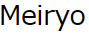
Meiryo is a very versatile modern sans serif type designed to give an exceptionally clean appearance on screen, as well as in print. It is optimized for on-screen reading. The letterforms are generously open and well-proportioned; legible and clear at smaller sizes, and dynamic at larger display sizes. The beauty of this face is that it sets text lines in Japanese with Roman seamlessly and harmoniously. The balanced inter-letter spacing enhances horizontal alignment, facilitating smooth reading flow. Meiryo has a very large character set with Japanese and Roman combined, fully scalable outline technology, making it extremely functional for all aspects of communication and publishing. It is a robust legible typeface yet compact enough to enable tight inter-line spacing which is good for space economy.

Windows SDK Sample OpenType Font Pack
These are sample fonts which is available for free in the Windows SDK under WPF\Documents\Typography\Fonts\Sample OpenType Font Pack. These are sample fonts which have a limited character range. If you desire full featured or custom versions of these fonts please contact the creator of these fonts, Ascender Corporation (http://www.ascendercorp.com).
Pericles
Kootenay
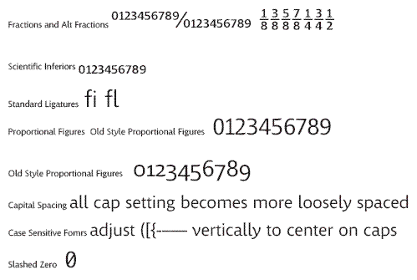

Pescadero
- 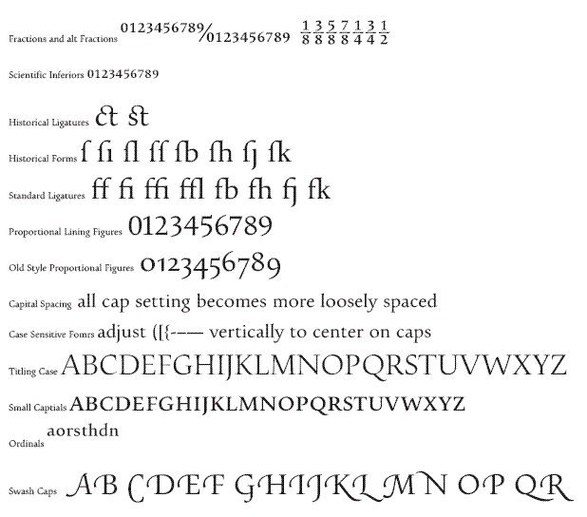

If the Solution Explorer pane is not visible, on the main menu click View and then click Solution Explorer.

